Regulatory Committee
Meeting to be held on 13 May 2015

Electoral Division affected:
Wyreside

Wildlife and Countryside Act 1981
Definitive Map Modification Order Investigation
Application to delete part of Public Footpath 22 Pilling and add a parallel Public Footpath at Field House, Pilling
File No. 804-553
(Annex ‘A’ refers)

Contact for further information:
Megan Brindle, 01772 535604, Legal and Democratic Services, megan.brindle@lancashire.gov.uk
Jayne Elliott, 07917 838826, Environment Directorate, Jayne.elliott@lancashire.gov.uk

Executive Summary

Application to delete part of Public Footpath 22 Pilling from the Definitive Map and Statement of Public Rights of Way and to add a parallel Public Footpath at Field House, Pilling, in accordance with file no. 804-553.

Recommendation

That the application to delete part of Public Footpath 22 Pilling from the Definitive Map and Statement of Public Rights of Way, and shown by a thick dashed line between points A-B-C-D-F, in accordance with File No. 804-553, be not accepted.

That the application to add a Public Footpath parallel to the section proposed for deletion to the Definitive Map and Statement of Public Rights of Way, and shown by a thick dashed line between points A-E-F, in accordance with File No. 804-553, be not accepted.

Background

An application under Schedule 14 of the Wildlife and Countryside Act 1981 has been received from the owner of Field House, Pilling for the deletion of part of Public Footpath 22 Pilling as shown by a thick dashed line between points A-F via B-C-D on the Committee plan and a distance of approximately 130 metres and for the addition of a Public Footpath shown by a thick dashed line between points A–F via E on the Committee plan for a distance of approximately 130 metres on the Definitive Map and Statement of Public Rights of Way.

The County Council is required by law to investigate the evidence and make a decision based on that evidence as to whether a public right of way exists, and if so its status. Section 53(3)(b) and (c) of the Wildlife and Countryside Act 1981 set out the tests that need to be met when reaching a decision; also current Case Law needs to be applied.

An order will only be made to add a public right of way to the Definitive Map and Statement if the evidence shows that:
- A right of way “subsists” or is “reasonably alleged to subsist”

An order for deleting a way shown on the Definitive Map and Statement will be made if the evidence shows that:
- That there is no public right of way over land shown in the map and statement as a highway as any description

An order for modifying the particulars contained within the Definitive Statement as to the position, width, limitations or conditions will be made if the evidence shows that:
- The particulars contained in the Definitive Map and Statement require modification

When considering evidence, if it is shown that a highway existed then highway rights continue to exist (“once a highway, always a highway”) even if a route has since become disused or obstructed unless a legal order stopping up or diverting the rights has been made. Section 53 of the Wildlife and Countryside Act 1981 (as explained in Planning Inspectorate’s Advice Note No. 7) makes it clear that considerations such as suitability, the security of properties and the wishes of adjacent landowners cannot be considered. The Planning Inspectorate’s website also gives guidance about the interpretation of evidence.

The County Council’s decision will be based on the interpretation of the evidence discovered by officers and documents and other evidence supplied by the applicant, landowners, consultees and other interested parties produced to the County Council before the date of the decision. Each piece of evidence will be tested and the evidence overall weighed on the balance of probabilities. It is possible that the Council’s decision may be different from the status given in any original application. The decision may be that the routes have public rights as a footpath, bridleway, restricted byway or byway open to all traffic, or that no such right of way exists. The decision may also be that the routes to be added or deleted vary in length or location from those that were originally considered.

Consultations

Wyre Borough Council have been consulted and no response has been received, it is assumed they have no comments to make.

Pilling Parish Council have been consulted and have stated that whilst the Councillors accept the principle of moving the footpath and appreciate that there is little impact providing the footpath is not removed, they consider that it would be more advisable to keep to Field House Lane, as it is a cleaner route, until the stile at the entrance to Field House (point C on the Committee plan) before diverting into the field.

Applicant/Landowners/Supporters/Objectors

The evidence submitted by the applicant/landowners/supporters/objectors and observations on those comments are included in Advice – Head of Service – Legal and Democratic Services Observations

Advice

Head of Service – Planning and Environment Observations

Points annotated on the attached Committee plan.

Point | Grid Reference (SD) | Description
A | 4119 4830 | Point on Pilling Footpath 22 immediately adjacent to rear north west corner of boundary fence of Provident House.
B | 4116 4830 | Point on access track recorded as Pilling Footpath 22 between gateposts marking the point at which ownership of the land changes.
C | 4115 4829 | Wooden stile and concrete gatepost situated in fence on south side of access track carrying Pilling Footpath 22.
D | 4113 4829 | Point at which Pilling Footpath 22 turns south west adjacent to Field House.
E | 4112 4827 | Point at which Pilling Footpath 22 turns west.
F | 4107 4827 | Unmarked point on Footpath 22 in field immediately south of boundary fence of Field House.

In the interests of clarity the routes will be referred to within this report as follows:
Route 1 – the route which the application seeks to delete and shown on the Committee plan as A-B-C-D-F.
Route 2 – the route which the application seeks to add and shown on the Committee plan as A-E-F.

This application is believed to have arisen due to a disagreement about the correct position of Pilling Footpath 22 on the ground. The applicant purchased Field House at a public auction in September 2005, has subsequently converted it and now lets it as a detached family home.

Following representations made on behalf of the applicant to the County Council in 2012 about the exact alignment of the footpath on the ground an undertaking was made to provide the applicant with a plan showing the position of the public footpath in relation to the property.

Field House is separated from the adjacent field to the south by a fence and hedge and the footpath is shown on the Definitive Map with thick imprecise dashes on a 1950s base map.

The Environment Director, in the letter dated 14 February, concluded that the public footpath had historically followed an enclosed track (as shown on the 1932 OS Map detailed later in the report) and that in part the current boundary of Field House coincided with the southern boundary of the formerly enclosed footpath and hence the public footpath was within the garden for much of the southern edge of the garden (between point E to point F on the Committee plan). However, it was concluded that at the eastern end of the garden the changes in the boundary position were not so clear, in part because of the changes to the out buildings, and that the footpath now runs along the boundary, partially inside and partially outside the Field House boundary (between point D and point E).

The precise location and width of the existing footpath is not recorded in the Definitive Statement but in such cases, if the route was enclosed between two defined highway boundaries when it was originally recorded (or came into being) it would normally be taken to be recorded as being the full available width. The track shown on the 1932 25 inch Ordnance Survey Map is approximately 4 metres wide around Field House suggesting that the width of the footpath that would have been available to the public would have been 4 metres.

The plans inserted below were provided to the applicant to show the position of the footpath along the current boundary of Field House and showed that it appeared to fall partially inside and partially outside the boundary.

First Definitive Map line (continuous dark purple) overlaid on modern base map (red lines) with digitised working copy of public rights of way (red dashes for the route in question, purple dashes for other public footpaths) | 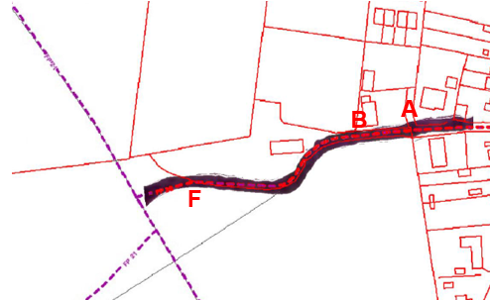
1932 Ordnance Survey 25 inch Map overlaid on modern OS base map, as supplied to applicant | 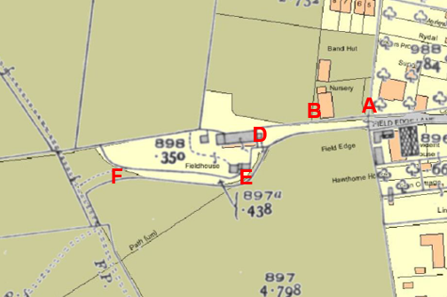

As a consequence of the provision of this information the applicant (landowner) submitted the applications that are being considered by the Committee in this report.

The applicant seeks to record the route of the public footpath from point A on the Committee plan as being in the field on the south side of the bounded access track between point A – D and continuing in a generally south westerly and then westerly direction along the field edge on the south side of the current boundary fence/hedge of Field House (Route 2) and to delete the route of Pilling Footpath 22 from running along the access track or through any part of Field House (Route 1).

This report will look at all the relevant historical maps and documents available to determine whether the original assessment made by the County Council was correct and determine the exact alignment the Pilling Footpath 22 in proximity to Field House. It will also look at whether the claimed route for addition correctly depicts the historical route of the Public Footpath or whether there is evidence to support the view that this route has subsequently come into existence.

Description of Routes

A site inspection was carried out in October 2014 and a further inspection was made in March 2015.

Pilling Footpath 22 leaves Lancaster Road to follow a stone surfaced access track between Coleraine and Provident House in a westerly direction for a distance of approximately 55 metres to point A. This section of the route is known locally, and marked on Ordnance Survey maps, as Field Edge Lane.

Route 1

Route 1 is shown on the County Council's digitised (working copy) public rights of way map as being the one depicted by a thick dashed line on the Committee plan between points A-B-C-D-F. However, the digitised line does not illustrate the full (unrecorded) width of the public footpath and thus could appear misleading as it appears to show Route 1 entirely within the garden of Field House whereas it actually overlaps the boundary in parts.

From point A Route 1 (recorded as Pilling Footpath 22) continues west along an enclosed stone surfaced track with grass down the central strip towards Field House. There is no gate across the track near point A although a rusty post is located on the north side of the track which looks like the gate post shown on a photograph submitted by the applicant which is discussed later in the report.

Approximately 30 metres further along the track from point A the route passes between some old concrete gateposts at point B where there is also a metal field gate in the fence along the south side of the track providing access into the adjacent field. This gate was tied shut when the route was inspected and didn't appear to have been recently used.

From point B the surface of the route changes to loose gravel and after a further 8 metres there is a wooden stile in the fence on the south side of the track at point C. This stile has been waymarked with a yellow public footpath arrow directing walkers into the field. Immediately west of the stile is a concrete gatepost on which it is possible to see the remains of a painted yellow waymark arrow also pointing into the field.

From point C Route 1, north of the boundary, curves slightly to the south west to point D then straddling the fence/hedge continues south west to E then west along the north side of the garden hedge, i.e. inside the garden, to point F where it passes through the hedge into the field.

Route 2

Route 2 leaves the stone access track (Pilling Footpath 22) at point A to pass through a metal field gate (open on the day of inspection) into the pasture field. It then continues along the edge of the field south of the enclosed access track past the wooden stile at point C and follows the field edge south west then west on the south side of the Field House boundary to point F.

Map and Documentary Evidence

Document Title | Date | Brief Description of Document & Nature of Evidence
Yates’ Map  of Lancashire | 1786 | Small scale commercial map. Such maps were on sale to the public and hence to be of use to their customers the routes shown had to be available for the public to use. However, they were privately produced without a known system of consultation or checking. Limitations of scale also limited the routes that could be shown.
Observations |  | The routes under investigation are not shown.
Investigating Officer's Comments |  | The routes under investigation did not exist as major routes at that time. They may have existed as minor routes but due to limitations of the scale would not have been shown so no inference can be drawn in this respect.
Greenwood’s Map of Lancashire | 1818 | Small scale commercial map. In contrast to other map makers of the era Greenwood stated in the legend that this map showed private as well as public roads and the two were not differentiated between within the key panel.
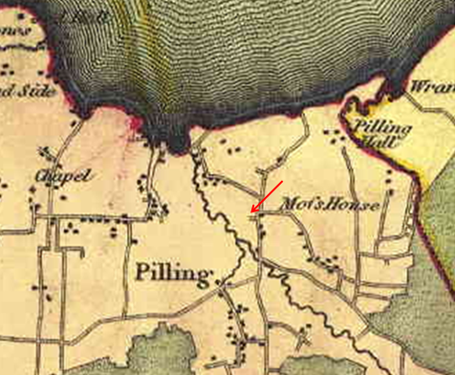
Observations |  | The start of Pilling Footpath 22 as it leaves Lancaster Road appears to be shown extending west towards point A. Field House and the routes under investigation are not shown.
Investigating Officer's Comments |  | The routes under investigation did not exist as major routes at that time. They may have existed as minor routes but due to limitations of the scale would not have been shown so no inference can be drawn in this respect.
Hennet's Map of Lancashire | 1830 | A further small scale commercial map. In 1830 Henry Teesdale of London published George Hennet's Map of Lancashire surveyed in 1828-1829 at a scale of 7½ inches to 1 mile. Hennet’s finer hachuring was no more successful than Greenwood’s in portraying Lancashire’s hills and valleys but his mapping of the county's communications network was generally considered to be the clearest and most helpful that had yet been achieved.
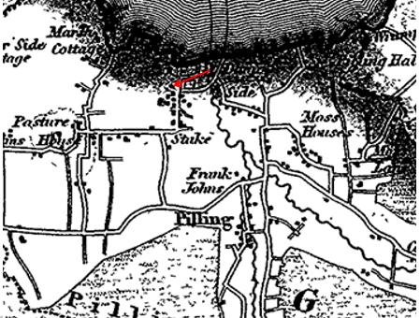
Observations |  | A route which appears to be the start of Pilling Footpath 22 from Lancaster Road is shown extending towards point A but Field House and the routes under investigation are not shown.
Investigating Officer's Comments |  | The routes under investigation did not exist as major routes at that time. They may have existed as minor routes but due to limitations of the scale would not have been shown so no inference can be drawn in this respect.
Canal and Railway Acts |  | Canals and railways were the vital infrastructure for a modernising economy and hence, like motorways and high speed rail links today, legislation enabled these to be built by compulsion where agreement couldn't be reached. It was important to get the details right by making provision for any public rights of way to avoid objections but not to provide expensive crossings unless they really were public rights of way. This information is also often available for proposed canals and railways which were never built.
Observations |  | The routes under investigation did not cross land that was affected by the development of a railway or canal.
Investigating Officer's Comments |  | No inference can be drawn.
Tithe Map and Tithe Award or Apportionment | 1845 | Maps and other documents were produced under the Tithe Commutation Act of 1836 to record land capable of producing a crop and what each landowner should pay in lieu of tithes to the church. The maps are usually detailed large scale maps of a parish and while they were not produced specifically to show roads or public rights of way, the maps do show roads quite accurately and can provide useful supporting evidence (in conjunction with the written tithe award) and additional information from which the status of ways may be inferred.
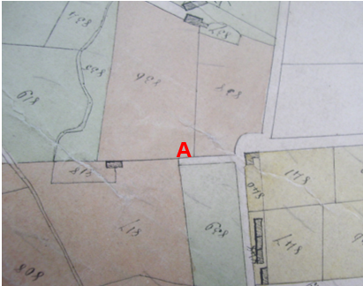
Observations |  | Neither of the routes under investigation are shown on the Tithe Map.  The map shows the first part of the route now recorded as Pilling Footpath 22 from Lancaster Road to point A uncoloured. Immediately west of point A there is a line drawn across the end of the uncoloured route and the land beyond it is coloured and the field numbered 817. The Tithe Schedule lists the owners of this land as Hornby Edward Esq, Gardner Esq, and Wilkinson Thomas Esq. and the occupier of the land as Thomas Wilkinson. The plot is described as 'House Field' and there is no reference to the existence of a public right of way.  A building is shown west of point A in the approximate position of Field House. No access track is shown to this building and it is included within the shaded plot no. 818 and described in the Tithe Schedule as 'House and garden'. The landowners are listed as being the same as for plot 817 and the occupier Thomas Wilkinson. There is no reference to a public right of way.
Investigating Officer's Comments |  | A house existed in the approximate location of Field House in 1845 but the means of accessing the property is not shown on the map. Neither route under investigation appeared to exist at that time.
Inclosure Act Award and Maps | 1847 and 1867 | Inclosure Awards are legal documents made under private acts of Parliament or general acts (post 1801) for reforming medieval farming practices, and also enabled new rights of way layouts in a parish to be made. They can provide conclusive evidence of status.
Observations |  | Pilling Lane Inclosure Map and Schedule dated 1847 and the Pilling Inclosure Award dated 1867 were inspected at the County Records Office.  Neither map covered the area crossed by the routes under investigation.
Investigating Officer's Comments |  | No inference can be drawn.
6 Inch Ordnance Survey (OS) Map | 1848 | The earliest Ordnance Survey 6 inch map for this area surveyed in 1844-45 and published in 1848.
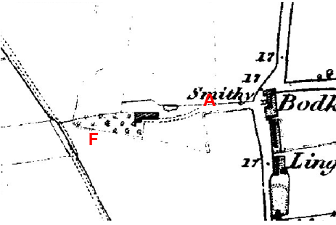
Observations |  | The map shows the start of Pilling Footpath 22 (Field Edge Lane) leaving Lancaster Road opposite Bodkin Hall as a substantial enclosed track to point A. From point A neither of the routes under investigation are shown although an unenclosed track (double pecked lines) is shown extending from point A to the front of an unnamed building that is in the same position as the existing building later known as Field House.
Investigating Officer's Comments |  | The building now know known as Field House existed in 1848 with access to it being along Pilling Footpath 22 to point A and then continuing to (but not past or beyond) the south face of the property. Neither Routes 1 or 2 appeared to exist at that time.
25 Inch OS Map | 1893 | The earliest OS map at a scale of 25 inch to the mile. Surveyed in 1890 and published in 1893.
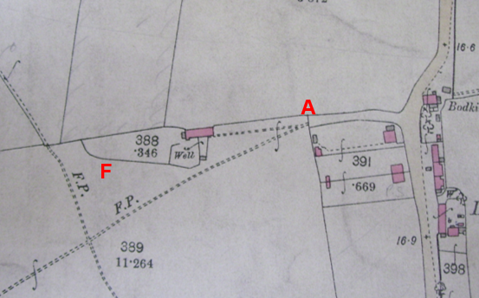
Observations |  | Access from Lancaster Road opposite Bodkin Hall and along Pilling Footpath 22 to point A is clearly shown as being along an enclosed track which is then gated immediately west of point A. From the gate there is a double pecked line annotated as a footpath (F.P.) which extends in a west south westerly direction to the intersection of 3 other routes which are also marked as footpaths. A double pecked line is also shown to extend from the gate directly to the building (Field House) but this is not annotated with the letters 'F.P' and does not continue around or beyond the property.
Investigating Officer's Comments |  | Neither Route 1 or 2 appear to have existed in 1893. A route that does not correspond to either of the routes appears to have existed on the ground at the time of the survey extending from point A but running to the south of either of the routes under investigation to link to the route now recorded as Pilling Footpath 21a.
25 inch OS Map | 1912 | Further edition of the 25 inch map surveyed in 1890, revised in 1910 and published in 1912.
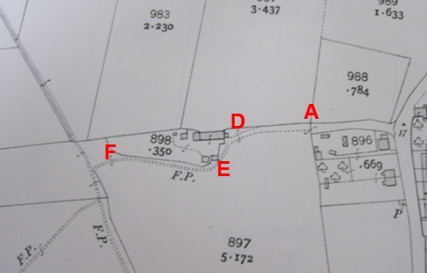
Observations |  | A gate is shown across the route now recorded as Pilling Footpath 22 immediately west of point A. Beyond the gate, extending in a westerly direction is an unenclosed track running through OS field No. 897. This track extends in a westerly direction towards Field House and is consistent with Route 1. The track then curves to continue in a south westerly direction and then more west north westerly direction to point F along the south side of the boundary of the property and within OS field No. 897 and is marked as a footpath (F.P.). It is difficult to align this map with the modern mapping (because there are insufficient common features that can be aligned) but as far as we can tell the F.P. shown would fall partially inside and partially outside the modern boundary of Field House between E and F.
Investigating Officer's Comments |  | By 1912, a footpath ran around what was then the perimeter of Field House. Although this route is marked as a footpath (F.P.) on the map there is no certainty when it actually became a public right of way but the map does indicate that a through route existed that linked to other routes that are now recorded as public footpaths and that it appeared to be capable of being used. It is not possible to determine the extent to which this footpath corresponds to Route 1 or Route 2.
Finance Act 1910 Map | 1910 | The comprehensive survey carried out for the Finance Act 1910, later repealed, was for the purposes of land valuation not recording public rights of way but can often provide very good evidence. Making a false claim for a deduction was an offence although a deduction did not have to be claimed so although there was a financial incentive a public right of way did not have to be admitted.  Maps, valuation books and field books produced under the requirements of the 1910 Finance Act have been examined. The Act required all land in private ownership to be recorded so that it could be valued and the owner taxed on any incremental value if the land was subsequently sold. The maps show land divided into parcels on which tax was levied, and accompanying valuation books provide details of the value of each parcel of land, along with the name of the owner and tenant (where applicable).  An owner of land could claim a reduction in tax if his land was crossed by a public right of way and this can be found in the relevant valuation book. However, the exact route of the right of way was not recorded in the book or on the accompanying map. Where only one path was shown by the Ordnance Survey through the landholding, it is likely that the path shown is the one referred to, but we cannot be certain. In the case where many paths are shown, it is not possible to know which path or paths the valuation book entry refers to. It should also be noted that if no reduction was claimed this does not necessarily mean that no right of way existed.
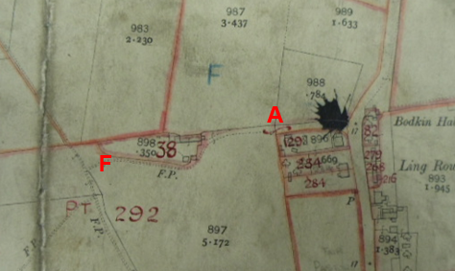
Observations |  | The Finance Act Map held by the County Records Office is drawn on the OS 25 inch base map published in 1912. It does not show either of the routes under investigation as being excluded from the numbered hereditaments. The enclosed (undisputed) section of Pilling Footpath 22 from Lancaster Road to point A is shown as being part of plot 292 which also includes the unenclosed access track to Field House and the continuation of the track around the outside of the southern boundary of Field House which is labelled as a footpath on the OS base map. The schedule held in the County Records Office details plot 292 as being owned by EGS Hornby, Dalton Hall, Burton, Westmorland and as being occupied by Mr Wilkinson. No deduction is listed for public rights of way or user.  Plot 38 is also owned by EGS Hornby but is occupied by Robert Bureer. It is described as 'House' and 'Fields Cottage, Stakepool'. No deduction is listed for public right of way or user.
Investigating Officer's Comments |  | All the land crossed by the routes under investigation were in the same ownership at the time that the valuation was carried out although the property (Field House) and field where occupied by different tenants. No deductions were listed for the existence of public rights of way or user across either of the plots suggesting that the landowner at that time did not accept the existence of any pubic rights of way or chose not to claim a deduction for them.  The Valuation Field books have not been requested from the National Records Office.
25 Inch OS Map | 1932 | Further edition of 25 inch map (surveyed 1890, revised in 1930 and published 1932).
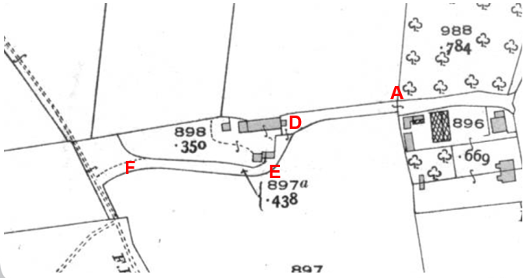
Observations |  | By 1930 it can be seen that the route around Field House has become an enclosed track between fences or hedges. Access along the track appeared to be gated just west of point A and just south east of the house but the whole length of the enclosed route from Lancaster Road through point A to point F and including a small area of land north west of point F is braced together and numbered as OS parcel no. 897a. The enclosed track is consistent with the alignment of the full length of the definitive route of Pilling Footpath 22 and is shown connecting to another route labelled as a 'F.P' (footpath). The width of the enclosed track measured from the map is approximately 4 metres.  Route 2 from point A running parallel to and south of the enclosed track (between point A and point D) is not shown. It is not clear whether there would have been access into the field from point A although the field boundaries are offset so it may have been possible that a stile or gate may have provided access directly into the field from this point.
Investigating Officer's Comments |  | Route 1 existed on the ground as an enclosed track which was approximately 4 metres wide in 1930.  Route 2 did not exist in 1930.
Site Measurements and OS MasterMap overlaid with 1932 3rd Edition OS 25 inch Map |  | Key to the interpretation of the OS map evidence is whether the current boundary fence/hedge of Field House is consistent with either boundary of the enclosed track shown on the 1932 25 inch OS Map. (The 1932 is used because it is the earliest map which can be satisfactorily aligned with modern mapping sufficiently and because it is based on the same survey used for the base-map for the 1st Definitive Map.) In addition to the overlay provided to the applicant a further version is shown below. These were produced using photo-editing software by digitally removing the solid white background from the 1932 map, replacing the black lines with colour (to distinguish them from the lines on the MasterMap) and adjusting the size & alignment (without skewing) to best match the MasterMap on which it is overlaid.
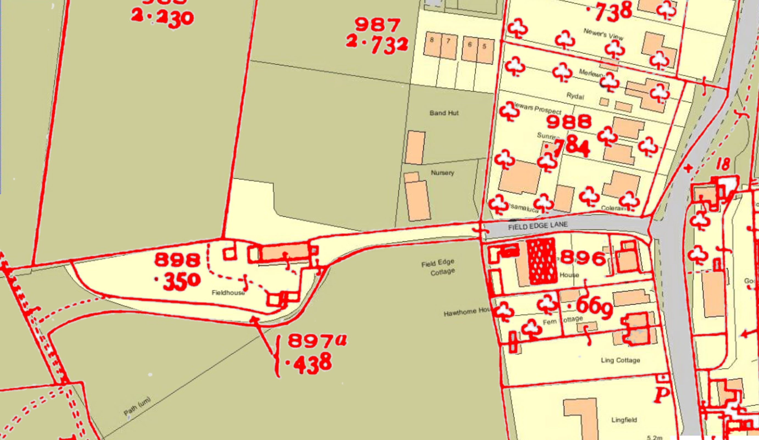
Having overlaid the 1932 Map with the modern MasterMap site measurements were then taken to check that the modern Ordnance Survey map accurately reflected what was on the ground.

Modern OS Map showing points from which measurements were taken on site: 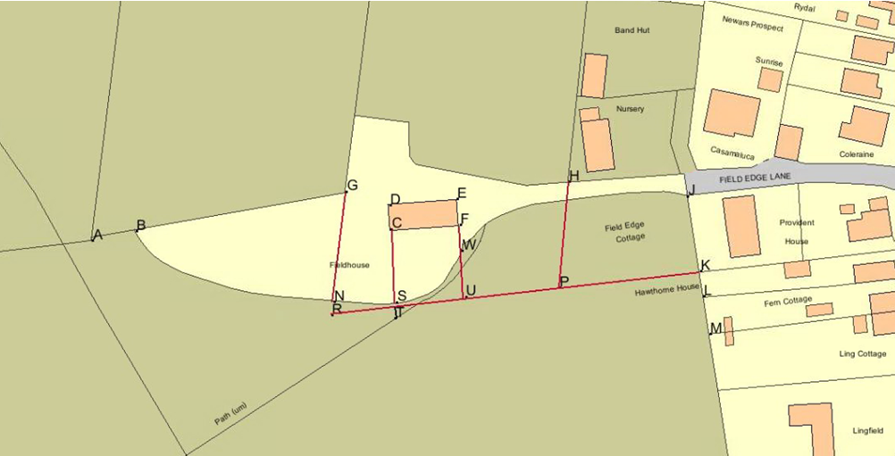
Table of measurements taken on site in October 2014 in comparison to measurements taken from modern OS base map:

Length measured | On Site measurement (metres) | Modern OS base map (metres)
C-S | 19.36 | 18.89
D-C | 6.11 | 6.76
C-F | 18.16 | 17.76
E-F | 6.36 | 6.75
F-W | 5.65 | 7.22
E-H | 27.58 | 28.9
G*-D | 12.07 | 11.57
G*-N | 24.4 | 26.6
G*-G | 1.5 | Not possible to measure from map

G* - measured from tree south of G on plan – the intersection of N-S field boundary with alignment of the northern wall of the house.
n.b. Site measurements were taken using a laser distance meter (Stanley TLM99). Map measurements were made using the measurement tool on ESRI ArcView GIS.

Observations |  | At a site inspection carried out in October 2014 measurements were taken to establish which (if either) historical boundary of the track coincided with the current boundary of the property with the field. The measurements taken suggest that the modern OS MasterMap does reflect the reality on site with a tolerance of ±½m. However, the fairly new fence at point W is closer to the house than the OS MasterMap suggests. It was also noted that there was a greater difference between the site and map measurements between points E-H but this could be accounted for because the distance was outside the range of the laser measurement tool in the prevailing light conditions.  It should also be noted that the position of point G and point G* is imprecise as there was no clear physical feature to measure from.  The site survey confirmed that the current boundary of the property reflects more closely that of the southern boundary of the enclosed track shown in 1932 and this confirmed the County Council's original view that at least part of the approximately 4 metre wide enclosed track that existed in the 1930s had subsequently became absorbed into the garden of Field House.  Use of the overlay confirms the measurements taken on site and the view that the historical route of the footpath lies predominantly within the garden of Field House between point D and point F. i.e. that Route 1 and not Route 2 existed in the 1930s.
Investigating Officer's Comments |  | Route 1 existed on the ground as an enclosed track which was approximately 4 metres wide in 1930 and now lies predominantly within the garden of Field House between point D and point E as shown on the overlaid map.
Aerial Photograph | 1940s | The earliest set of aerial photographs available was taken just after the Second World War in the 1940s and can be viewed on GIS. The clarity is generally very variable.
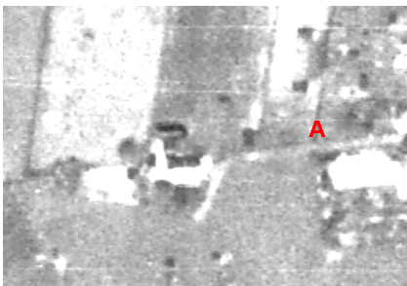
Observations |  | The quality of the photograph is poor and the necessary detail required cannot be seen.
Investigating Officer's Comments |  | No inference can be drawn.
6 Inch OS Map | 1955 | The OS base map for the Definitive Map, First Review, was published in 1955 at a scale of 6 inches to 1 mile (1:10,560). This map was revised before 1930 and is probably based on the same survey as the 1930s 25-inch map.
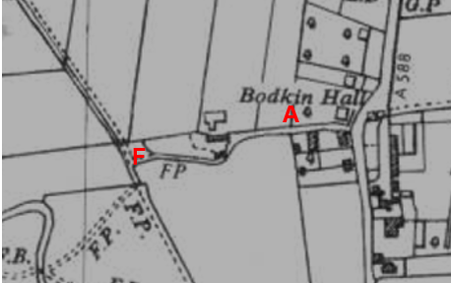
Observations |  | Route 1 is shown as an enclosed track as it was shown on the 1932 25 inch Ordnance Survey Map. Route 2 is not shown on the map.
Investigating Officer's Comments |  | The route available to be used by the public during the 1950s when the Definitive Map was being prepared was likely to be the enclosed track along which the definitive route of Pilling Footpath 22 was recorded.  Route 2 probably did not exist in 1955.
Aerial photograph | 1960s | The black and white aerial photograph taken in the 1960s and available to view on GIS.
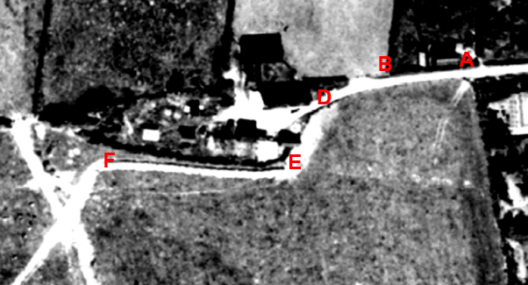
Observations |  | Route 1 can be clearly seen as a worn track between point A-B and continuing to point D. Beyond point D a light coloured strip indicative of a substantial track can be seen both into Field House and also outside the curtilage in a south westerly direction passing close to two small buildings which are within the curtilage of Field House (as shown on the 1932 25 inch OS). It is not possible to see whether this worn track is enclosed from the field. The worn track then turns at point E to continue in a more westerly direction to point F but it appears that immediately to the north of the visible track is a fence or hedge then a gap and then another fence/hedge. Between these two hedges/fences there appears to be an enclosed strip of land which is open and accessible at either end and a worn trod is visible along this strip.  From point A access appears to be available into the field south of the track but there is no worn track parallel to the access road along the field edge (Route 2).
Investigating Officer's Comments |  | In the 1960s it appears that access along Route 1 was available along a clearly defined access track from point A to point D. From point D in a south westerly direction a substantial track – probably created by farm vehicles and/or animals - can be seen. It is not clear whether this would be inside, outside or straddling the modern fence. From point E it then appears that the farm vehicles/animals were taking a route on the south side of the enclosed strip that was shown clearly as the track around the property on the 1932 OS map although the enclosed section from point E to point F can still be seen. The photograph suggests that whilst this part of Route 1 may still have been useable a track had now come into being on the outside of the southern boundary consistent with part of Route 2 (point E to point F) but there is no indication that this use was public.
1:2500 OS Map SD 4048 & SD 4148 | 1968 | Further edition of 25 inch map reconstituted from former county series and revised in 1967 and published 1968 as national grid series.
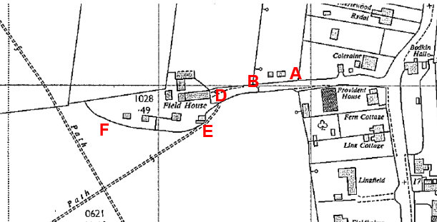
Observations |  | By 1967 it appears that access was no longer gated just west of point A but that a gate had been erected across the route at point B. An enclosed track is still shown between point A and point D which is consistent with the Definitive Map route of Pilling Footpath 22. West of point D access to Field House (now labelled as such on the map) appears to be gated with a track (double pecked line) and labelled as 'path' passing from point D to point E and then continuing in a south westerly direction to an intersection of paths. Field House appears to have expanded with a number of additional outbuildings shown. The enclosed track shown on the 1932 OS map is no longer evident and the boundary of the curtilage from the field to the south between point E and point F is consistent with that shown as the southerly boundary of the former track which has effectively been absorbed into the garden.
Investigating Officer's Comments |  | The existence of gates across a track leading to farm premises does not necessarily preclude public access as many public rights of way are gated.  It appears likely that access along Route 1 would still have been available in 1968 along the enclosed track to point D and then south west to point E. Between point E and point F access no longer appeared to be available along Route 1 but may have been available along Route 2. However, a worn track was identified by the Ordnance Survey and marked as a 'Path' to the south suggesting an alternative route may have been in use instead.  The map does not provide any evidence that a route existed on the field edge south of the enclosed track between point A and point D.
Aerial Photograph | 1988 | Aerial photograph available to view at the County Records Office and LCC Cuerden Depot.
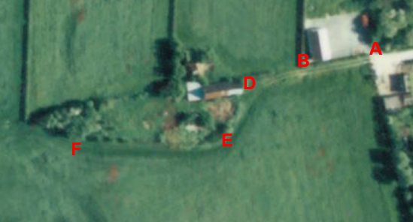
Observations |  | By 1988 it appears that the property had fallen into disrepair and few of the outbuildings that could be seen on the 1960s 25 inch OS can be identified.  The track between point A-B-D can be seen but appears to have largely grassed over and no longer appears to be separated from the field to the south.  The boundary around Field House looks to have largely been broken down or collapsed and is poorly defined but a darker green strip which may have been the remnants of a track around the outside edge can still be seen in the grass.
Investigating Officer's Comments |  | It still appears that the public could be using Route 1 along the track from point A to point D and would then follow Route 2 on the edge of the field around the south side of the broken property boundary to point F. It is not possible to determine whether the boundary on this photograph corresponds to any older boundary or track.
Aerial Photograph | 2000 | Aerial photograph available to view on GIS.
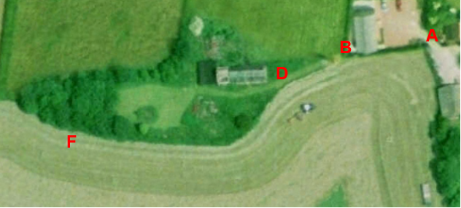
Observations |  | The means of access immediately west of point A is unclear but could have been gated. The former track to Field House is no longer visible and the route now appears to completely grassed over forming part of the field to point B from where a mown track can be seen leading to the property which may have been fenced on the south side but it is difficult to see. Grass from the field has been recently cut making it difficult to see whether any worn tracks existed.
Investigating Officer's Comments |  | It is not possible to see from the photograph any route used at the time.
Aerial Photograph |  | Most recent aerial photograph available on GIS
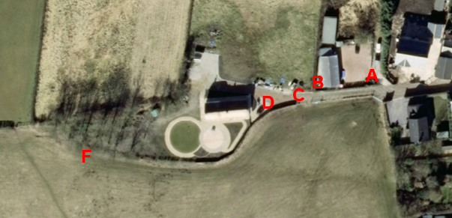
Observations |  | By the time that this photograph was taken the property had been redeveloped. The access track had been reinstated between point A and point D and new fencing erected around the property boundary. The route from point A along the track appears to be open and a gate can be seen south of point A providing access into the field south of the access track.
Investigating Officer's Comments |  | The fenced off access track between point A and point D had been reinstated as access to Field House and appeared to be accessible to the public. It was not possible to see from the photograph whether the stile existed at point C but access beyond point C appears to have been more likely to have been along the field edge, Route 2, rather than through the garden, Route 1.
Definitive Map Records |  | The National Parks and Access to the Countryside Act 1949 required the County Council to prepare a Definitive Map and Statement of Public Rights of Way.  Records were searched in the Lancashire Records Office to find any correspondence concerning the preparation of the Definitive Map in the early 1950s.
Parish Survey Map | 1950-1952 | The initial survey of public rights of way was carried out by the parish council in those areas formerly comprising a rural district council area and by an urban district or municipal borough council in their respective areas. Following completion of the survey the maps and schedules were submitted to the County Council. In the case of municipal boroughs and urban districts the map and schedule produced, was used, without alteration, as the Draft Map and Statement. In the case of parish council survey maps, the information contained therein was reproduced by the County Council on maps covering the whole of a rural district council area. Survey cards, often containing considerable detail exist for most parishes but not for unparished areas.
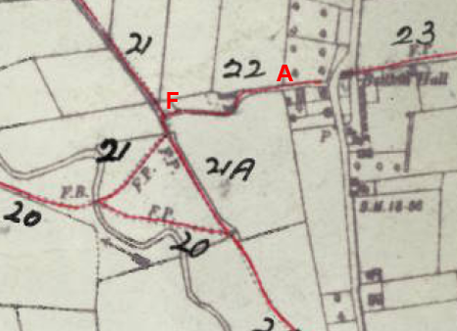
Observations |  | The parish survey was prepared for Pilling in 1950 when the maps and survey cards were produced. The parish survey card provides no useful information about the location of the route other than its starting point and destination and that it was considered to be in 'fair condition'. The footpath has been drawn to follow the access track right up to the eastern side of the building that is now known as Field House and then south to point E within the boundary of Field House and then west with the red line drawn along the boundary of the property to point F. The maps were hand drawn using Ordnance Survey maps at a scale of 6 inches to 1 mile as a base.
Draft Map |  | The parish survey map and cards for Pilling were handed to Lancashire County Council who then considered the information and prepared the Draft Map and Statement.  The Draft Maps were given a “relevant date” (1st January 1953) and notice was published that the draft map for Lancashire had been prepared. The draft map was placed on deposit for a minimum period of 4 months on 1st January 1955 for the public, including landowners, to inspect them and report any omissions or other mistakes. Hearings were held into these objections, and recommendations made to accept or reject them on the evidence presented.
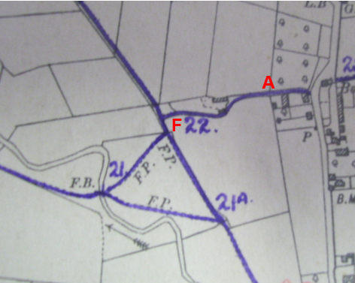
Observations |  | The route of Footpath 22 Pilling is clearly shown to follow the access track existing at that time through point A and point B towards Field House. It is not shown to go right up to Field House like it was shown on the Parish Survey map but curves round consistent with Route 1 with the thick purple line depicting the route having been drawn along the boundary of the 6 inch OS base map between points D-E-F.
Provisional Map |  | Once all representations relating to the publication of the draft map were resolved, the amended Draft Map became the Provisional Map which was published in 1960, and was available for 28 days for inspection. At this stage, only landowners, lessees and tenants could apply for amendments to the map, but the public could not. Objections by this stage had to be made to the Crown Court.
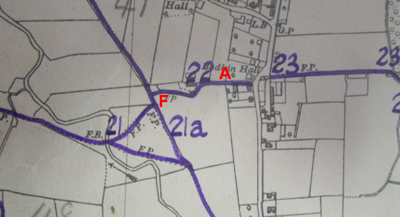
Observations |  | The route shown on the Provisional Map is consistent with the route shown on the Draft Map.
The First Definitive Map and Statement |  | The Provisional Map, as amended, was published as the Definitive Map in 1962.
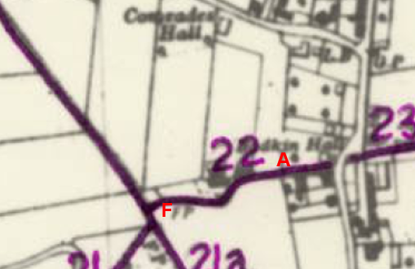
1st Definitive Map line (continuous dark purple) overlaid on modern base (Ordnance Survey Master-Map) with digitised working copy of public rights of way (red dashes) | 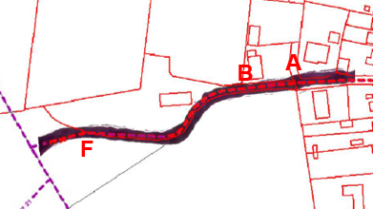
Observations |  | The First Definitive Map shows the route of Pilling Footpath 22 following the enclosed track around the property, Route 1, and does not show Route 2, the route applied to be added.
Revised Definitive Map of Public Rights of Way (First Review) |  | Legislation required that the Definitive Map be reviewed, and legal changes such as diversion orders, extinguishment orders and creation orders be incorporated into a Definitive Map First Review. On 25th April 1975 (except in small areas of the County) the Revised Definitive Map of Public Rights of Way (First Review) was published with a relevant date of 1st September 1966. No further reviews of the Definitive Map have been carried out. However, since the coming into operation of the Wildlife and Countryside Act 1981, the Definitive Map has been subject to a continuous review process.
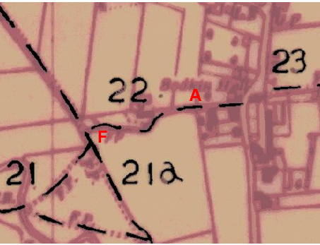
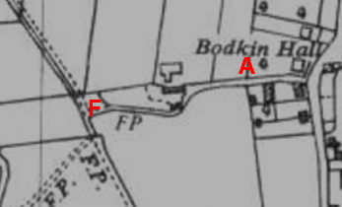
Observations |  | The Definitive route of Pilling Footpath 22 is again shown as being along the enclosed route and had not been legally altered or diverted from the route shown on the First Definitive Map. The first of the two map extracts above is an enlarged copy of the current Definitive Map (First Review). The map immediately below it is an extract of the Ordnance Survey base map used for the Definitive Map (First Review) showing more clearly the enclosed track along which the Definitive Map line of the footpath was drawn.
Investigating Officer's Comments |  | It is recognised that the hand-drawn lines of the various maps used in the Definitive Map process lack the precision of the Ordnance Survey base on which they were drawn. However, the maps produced as part of the process leading to the current legal document (the Definitive Map & Statement of Public Rights of Way) all show Public Footpath 22 Pilling in the same position – following the formerly enclosed track between point A and point F.
Statutory deposit and declaration made under section 31(6) Highways Act 1980 |  | The owner of land may at any time deposit with the County Council a map and statement indicating what (if any) ways over the land he admits to having been dedicated as highways. A statutory declaration may then be made by that landowner or by his successors in title within ten years from the date of the deposit (or within ten years from the date on which any previous declaration was last lodged) affording protection to a landowner against a claim being made for a public right of way on the basis of future use (always provided that there is no other evidence of an intention to dedicate a public right of way).  Depositing a map, statement and declaration does not take away any rights which have already been established through past use. However, depositing the documents will immediately fix a point at which any unacknowledged rights are brought into question. The onus will then be on anyone claiming that a right of way exists to demonstrate that it has already been established. Under deemed statutory dedication the 20 year period would thus be counted back from the date of the declaration (or from any earlier act that effectively brought the status of the route into question).
Observations |  | No Highways Act 1980 Section 31(6) deposits have been lodged with the County Council for the area over which the route under investigation runs.
Investigating Officer's Comments |  | There is no indication by a landowner under this provision of non-intention to dedicate public rights of way over this land.
Photographs submitted by the Applicant |  | Undated photographs submitted by the applicant.
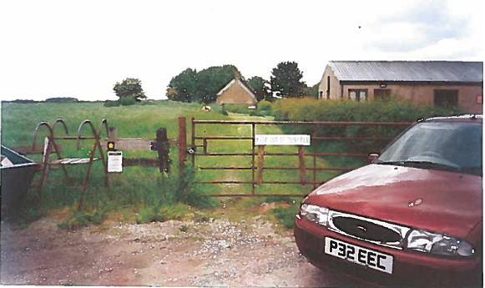
Photograph 1
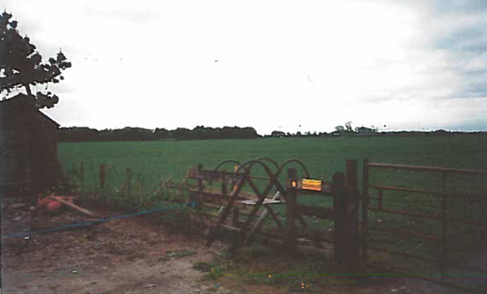
Photograph 2
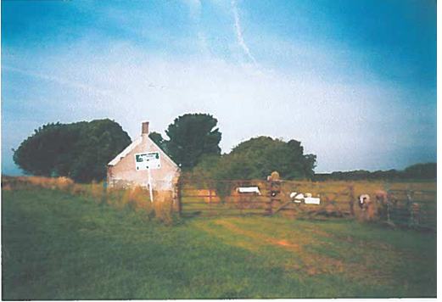
Photograph 3
Observations |  | Photograph 1 was submitted by the applicant attached to a copy of a letter sent to Mr W Lawrenson of Abram House by Lancashire County Council on 27 September 1993. The letter makes reference to both the stile and locked gate being within the width of the path and states that no illegal obstruction of the public right of way exists.  The photograph has been taken from Public Footpath 22 Pilling looking west to point A. Across the route at point A is a padlocked field gate with a sign attached saying 'Keep out of this Field' . Adjacent to the gate on the left (south) side is a metal ladder stile that has been waymarked with a yellow arrow. A notice is present below the waymark but it is not possible to see what it says.  The County Council letter gives the details of the LCC PROW Inspector that was responsible for the area at that time – Mr J Shaw – and the car that can be seen on the photograph is known to have been owned by Mr Shaw suggesting that he took the picture when he inspected the footpath.  The applicant has stated that he purchased the property in 2005 but does not provide any information regarding whether or not he had knowledge of the area before that time.  With reference to the photograph the applicant states that the gate and adjacent stile had been in place for 40 years and that the gate was padlocked in 1985. However he provides no information regarding the basis of that knowledge.  Photograph 2 was also provided by the applicant. It is undated but the applicant states that the stile was "placed in position in 1971 alongside the access road to Field House to carry Footpath 22 into the field owned by Mr. Donald Lawrenson."' The applicant states that this was the case when he bought the property in 2005. He does not provide any evidence to substantiate his claim that the stile had been in position since 1971.  Photograph 3 is again undated but was submitted by the applicant and shows gated access into Field House at the time of the sale by public auction in September 2005. The gate is said by the applicant to have been erected in 1971 - no evidence is provided to substantiate this.
Investigating Officer's Comments |  | Photograph 1 shows that a field gate was locked across the Definitive Map route of Pilling Footpath 22 in 1993 and that the County Council did not appear to take any action at that time regarding the gate because a stile existed alongside it. A different view would now be taken in the same circumstances and although the gate may be accepted as a legal limitation or subsequently authorised the locking of it would not be considered acceptable. However this was common practice at that time. The access track beyond the gate is visible in the photograph and is not fenced off from the adjacent field suggesting that the public would still be able to walk along it after climbing over the stile and may have chosen to do so (as opposed to walking the route to be added) as the track would have been easier and likely to be drier underfoot.  No evidence is provided to substantiate the applicant's claim that the stile existed since 1971 so no inference can be drawn from this submission and it is not the view of the Investigating Officer that its existence at that location meant that Route 2 rather than Route 1 was in use. Furthermore, the situation in 1971 does not necessarily assist determination of where the public right of way was recorded in the 1950s.  Photograph 2 is undated and although the stile may have existed for a considerable period of time as stated above it is not the opinion of the Investigating Officer that its existence at that location proves that Route 2 was the one in public use instead of Route 1. It appears that the access track (Definitive Map route between point A-B-C) was not fenced off during the 1980s and 1990s and although unlawful it is not uncommon to find that landowners padlocked field gates across access tracks that carried public rights and provided adjacent stiles.  It is not possible to know from Photograph 3 whether the public went through the gate into the property or not. It would be irrelevant to the recording of the route in the 1950s as to whether a gate had existed at this location since 1971 as claimed by the applicant.
Legal Orders diverting, Stopping up or creating a Public Right of Way |  | A search has been made at the County Records Office and of the Public Rights of Way records to check whether any legal orders have been made since Pilling Footpath 22 was originally recorded on the Definitive Map and Statement to divert or to legally stop up any part of the route.
Observations |  | No legal Orders diverting or extinguishing any part of the route recorded as Pilling Footpath 22 have been found.
Investigating Officer's Comments |  | The route of Pilling Footpath 22 has never been legally altered since it was first recorded and still exists on that line irrespective of whether or not it can be physically walked.

The affected land is not designated as access land under the Countryside and Rights of Way Act 2000 and is not registered common land.

Landownership
The applicant Christopher John Kelly, Sale Wheel House, Dinkley, Ribchester, Preston PR3 3XU owns some of the land in connection with this application.
Donald William Lawrenson and Vera Lawrenson, Bonds Farm, Wheel Lane, Pilling, Preston PR3 6HN are also landowners of this application, part of this route is unregistered.

Summary

The primary question to be answered is "what is the precise route shown by the Definitive Map and Statement?" and a subsidiary question "is the Definitive Map and Statement correct?

On some date between 1189 and 1961 (between the start of legal memory and the relevant date of 1st Definitive Map and Statement) a public footpath came into being and was subsequently recorded as Pilling Footpath 22. In considering the line of this way the evidence leading up to the preparation of the 1st Definitive Map should be given significant weight and in the absence of any legal diversion, evidence after 1961 given relatively little weight. The greatest weight must be given to the 1st and 1st Review Definitive Map and Statement as the legally conclusive record of public rights of way at the relevant date.

The current (1st Review) Definitive Map and Statement is imprecise but the map is sufficiently clear when viewed in conjunction with a 'clean' copy of its base-map to show it follows the enclosed track around the then boundary of Field House.

The base-map used for the Definitive Map is the 1955 Ordnance Survey 6 inch map which was derived from a pre-1930 survey, almost certainly the same survey as the 1932 Ordnance Survey 25 inch map which can therefore be used to assist with precision. Therefore by measuring the position on the ground which corresponds to the position on these maps or by overlaying these maps on modern maps we can determine the correct position of Pilling Footpath 22.

The site survey confirmed that the current boundary of the property reflects more closely that of the southern boundary of the enclosed track shown in 1932 and this confirmed the County Council's original view that at least part of the approximately 4 metre wide enclosed track that existed in the 1930s subsequently became absorbed into the garden of Field House.
The County Council also constructed the overlay inserted above to compare the route of the enclosed track on the 3rd Edition 25 inch Ordnance Survey map with modern day features.
Use of the overlay confirms the measurements taken on site and the view that the historical route of the footpath lies predominantly within the garden of Field House between point D and point F and that Route 2 did not exist in the 1930s.

The second question is whether the Definitive Map and Statement is correct, bearing in mind the Trevelyan case which shows that the presumption should be that it is taken to be correct unless substantial evidence is produced to show otherwise.

The strongest support for the Definitive Map is from the 1st Definitive which shows the same line as does the draft and provisional that led to it. The parish survey map shows a very similar line except that it runs closer to the house near point D. The 1912 Ordnance Survey 25" map shows a similar line suggesting temporal continuity and that the line was established at some time between the1890 survey and 1910 revision.

There is no evidence supporting a consistent alternative line and post-1960s structures and boundary changes would constitute unlawful interference with and obstruction of the public right of way rather than evidence of either a lawful diversion or a correction to the legal record.

To conclude, it is considered that the route recorded as Footpath 22 Pilling as part of the Definitive Map process was correctly recorded as running along the enclosed track clearly identified on the 1932 3rd Edition 25 inch OS.

It is considered that the original (legal) route of the public footpath has probably not been capable of being walked in its entirety since some point in the 1960s and that it is now substantially within the boundary of Field House between points C and F.
The fact that the route between point C and point F has not been capable of being walked for such a period of time does not mean that it is no longer the legal route of the public footpath.

Because the Definitive Map route of part of the public footpath has been blocked it appears that the public have used an alternative route around the field edge but there is insufficient map and documentary evidence to identify the exact position of this route and insufficient user evidence to show it as an additional footpath. In any event this would not change the line of the public right of way which the applicant seeks to remove from his property.

Head of Service – Legal and Democratic Services Observations

Information from the applicant:

The applicant states he bought Field House, a derelict cottage owned by Mr. Walter Lawrenson (Abram House, Smallwood Hay Road, Pilling, Preston, PR3 6HE) at a public auction in September 2005 and has subsequently converted it into a modern detached family home.

He then states at the time of the purchase Footpath 22 Pilling passed along Field Edge Lane and at the western boundary of Provident House a stile carried the path into the field south of Field House. The field is owned by Donald Lawrenson brother of Walter (Bonds Farm, Duck Street, Pilling, Preston, PR3 6HN).
He has included photographs to support his application – photograph 1 shows the stile provided in 1971 taking the footpath into the field alongside the access road to Field House.

Mr Kelly then goes on to state that after he purchased Field House Mr Donald Lawrenson for some reason best known to himself arranged for the footpath to be moved along the access road to the house and to continue several metres into the front garden of Mr Kelly's property to a new stile provided by Mr Lawrenson to return the path into the field.

Documents provided by the applicant:

- Photograph 1 shows the stile placed in position in 1971 alongside the access road to Field House to carry Footpath 22 Pilling into the field owned by Mr Donald Lawrenson, this was the situation when the application bought the property in 2005.
- Documents showing research into the legal line of Public Footpath No 22 Pilling, the documents include:
- A letter from RPC, Temple Circus, Temple Way, Bristol, BS1 6LW in response to a complaint by Mr Kelly with concerns to the Local Authority Search report dated 9th September 2005 on behalf of PSG Franchising Limited – PSG reviewed the complaint submitted by Mr Kelly and their conclusion is as follows:
"Having reviewed your complaint, PSG are satisfied that the Report was prepared to a reasonable standard. PSG were only required to identify the footpath as it appeared on the Definitive Map. PSG are confident that this was achieved. We are not persuaded that the footpath does run through the property and there are obvious concerns with the Council's conclusions. However, even if the footpath does run through the property, this clearly indicates a discrepancy with the Definitive Map, for which PSG are not responsible. We therefore suggest that you address this directly with the Council."
- A letter from David Goode to Mr Kelly dated 14th February 2013, Mr Goode responds to Mr Kelly's letter regarding the correct legal line of Public Footpath 22 Pilling. The historical maps considered in Mr Goode's letter are Ordnance Survey 25" Map 1893, 1912 & 1931, Parish Survey Map 1951, Draft Map 1953, Provisional Map 1953, 1st Definitive Map 1953, Base for Definitive Map (Ordnance Survey 6" Map 1955), Definitive (1st review) Map 1966 and Current Ordnance Survey Master-Map. The conclusion to Mr Goode's letter is that in part the current boundary of Field House coincides with the southern boundary of the formerly enclosed footpath and hence the public footpath is within the garden for much of the southern edge of the garden. However, at the eastern end of the garden that changes in the boundary position are not so clear, in part because of the position of various outbuildings, and the footpath now runs along the boundary, partially inside and partially outside the Field House boundary. It is clear that it runs along the access drive to the eastern end of the building before straddling the fence for a short distance.
- Document 3 is a statement from the applicant, the applicant states it has proven very difficult to establish what is the legal line of Footpath 22 from the Definitive Map and Statement, he refers to the search carried out by PSG for the Auction details and the firm is very doubtful about the conclusions reached by the County Council team and have suggested that even if the footpath does pass through the property on the ground this is not evident from the Definitive Map.
The applicant disagrees with the conclusion reached by the County Council. The Council also seem confused as demonstrated when in the early 1990s the Council took the view that a padlocked gate across the access road (now considered by the Council to be the route of the path) to the Field House was not an illegal obstruction to the public right of way. The applicant then provides a copy of a County Council letter to Mr Walter Lawrenson dated 29th September 1993 together with photograph number which shows the padlocked gate.
When PSG a firm carrying out legal searches are unable to interpret the Definitive Map and the County Council also in similar difficulties there is in his view an overwhelming need to modify Footpath 22. This application for a Modification Order to delete the very complex section of what has been viewed by the County Council (with some difficulty) as the legal line of Footpath 22 in the vicinity of Field House.
The applicant then states the deleted section of Footpath 22 to be replaced by adding a section from the western boundary of Provident House through the field south of Field House. This proposed section of the footpath has, until recently, been in constant use for almost forty years with no objection from the owner, the owner will need to resite the stile he provided in the Field House boundary to near Provident House.
- A letter from Lancashire County Council to Abram House (next door to Field House / Provident House) dated 27th September 1993 regarding the matter of the metal stile and the padlocked gate. Their land search revealed that neither the public footpath nor Provident House were registered, but from a site inspection and measurements taken it was evident that both the stile and the gate were within the width of the path.
The County Surveyor was therefore satisfied that both are on Abrams land rather than that within the curtilage of Provident House and that no illegal obstruction of the public right of way exists.
- Photograph 2 shows the gate across the access road to Field House adjacent to the stile carrying footpath 22 into the Field, this situation has existed for almost 40 years and the gate was padlocked in 1985.
- Photograph 3 shows gated access to Field House at the time of sale by public auction in September 2005. (Gate provided 1971).

Information from other landowners

A letter has been received from Mr and Mrs Lawrenson, owners of the field south of Fieldhouse. They do not agree to move the footpath to the broken line as shown on the committee plan. They are happy to follow the footpath along the road to stile referenced A on a plan they submitted (point C on the Committee plan) and then move into the field and follow the new proposed section towards west.

Assessment of the Evidence

The Law - See Annex 'A'

In Support of the Proposal to add A-E-F

Available route
Acknowledgement of present landowner of part of route from just south of C to point F

Against Accepting the Proposal to add A-E-F

Insufficient evidence from documentary or user evidence
No present user evidence for the route acknowledged as acceptable by present landowner

In Support of the Claim to delete A-B-C-D-F

No real cogent evidence of error in 1966 sufficient to delete
Against Accepting the Claim to delete A-B-C-D-F

Initial presumption that it exists
The evidence needed to remove a public right from such an authoritative record will
need to be cogent
No objections to it being shown on the Definitive Map (First Review)

Conclusion
In this matter it is claimed that the line shown on the Definitive Map should be
deleted and another section be added.
It is advised that to remove a route from the Definitive Map it is necessary to show
on balance that it was put on the Definitive Map in error. In this matter the route to be
deleted (A-B-C-D-F) was first shown on the Definitive Map (First Revision) dated 1975 but with a relevant date of 1966 and so the error needs to be shown to have been made in 1966.
Case Law (Trevelyan) confirms that cogent evidence is needed before the Definitive
Map and Statement are modified to delete a right of way. Lord Phillips MR of the
Court of Appeal stated that:
“Where the Secretary of State or an inspector appointed by him has to
consider whether a right of way that is marked on a definitive map in fact
exists, he must start with an initial presumption that it does. If there were no
evidence which made it reasonably arguable that such a right of way existed,
it should not have been marked on the map. In the absence of evidence to the
contrary, it should be assumed that the proper procedures were followed and
thus that such evidence existed. At the end of the day, when all the evidence
has been considered, the standard of proof required to justify a finding that no
right of way exists is no more than the balance of probabilities. But evidence
of some substance must be put in the balance, if it is to outweigh the initial
presumption that the right of way exists. Proof of a negative is seldom easy,
and the more time that elapses, the more difficult will be the task of adducing
the positive evidence that is necessary to establish that a right of way that has
been marked on a definitive map has been marked there by mistake.”

One such evidence of error could be sufficient evidence of a correct route. In
caselaw (Leicestershire case) Collins J held that in these circumstance, “it is not
possible to look at s53(3)(c)(i) (adding a route) and s53(3)(c)(iii) (deleting a route) in
isolation because there has to be a balance drawn between the existence of the
definitive map and the route shown on it which would thus have to be removed” He
went on “if (the decision maker) is in doubt and is not persuaded that there is
sufficient evidence to show the correct route is other than that shown on the map,
then what is shown on the map must stay because it is in the interests of everyone
that the map is to be treated as definitive M where you have a situation such as you
have here, it seems to me that the issue is really that in reality section 53(3)(c)(iii) will
be likely to be the starting point, and it is only if there is sufficient evidence to show
that that was wrong – which would normally no doubt be satisfied by a finding that on
the balance of probabilities the alternative was right – that a change should take
place. The presumption is against change, rather than the other way round”.
.
It is therefore suggested that the Committee first consider whether the claimed
section A-E-F is already a footpath at law and should be added to the Definitive
Map and then whether this means that it was the correct route of the footpath
network in 1966 and therefore the route A-B-C-D-F was recorded as on the Definitive
Map in error in 1966.

It is suggested that Committee, having considered the map and documentary evidence presented, may consider that there is no evidence by way of the
maps and documentary evidence that the route A-E-F was already a footpath in law by 1966 . More recently the present owners seem content that there be a public footpath south of the fenceline on their land from the stile at point C westwards to point F but at the present time there is no evidence of public user for that modern route. A dedication of a highway by an owner needs evidence of acceptance by the public. There may well shortly be evidence of a modern footpath coming into existence but not one in existence in 1966 and therefore no evidence on balance of an alternative route in 1966 to indicate an error in recording line A-B-C-D-F as Footpath 22.

Committee is therefore advised to look at the evidence to see if the recording of Footpath 22 on A-B-C-D-F was in error. It is suggested that there is no cogent evidence of such an error. The enclosed route which used to exist at this location was recorded as carrying the line of the public route. It is advised that the evidence is not sufficient to overcome the presumption that it exists. There is no sufficient cogent evidence to satisfy the test to delete the footpath.

It is therefore advised that the application to delete be not accepted and the application to record a public footpath on A-E-F also be not accepted

Alternative options to be considered - N/A

Local Government (Access to Information) Act 1985

List of Background Papers

Paper | Date | Contact/Directorate/Tel
All documents on File Ref: 804-553 | Various | Megan Brindle , 01772 535604, Legal and Democratic Services
Reason for inclusion in Part II, if appropriate

N/A

The Ordnance Survey (OS) has produced topographic maps at different scales (historically one inch to one mile, six inches to one mile and 1:2500 scale which is approximately 25 inches to one mile). Ordnance Survey mapping began in Lancashire in the late 1830s with the 6-inch maps being published in the 1840s. The large scale 25-inch maps which were first published in the 1890s provide good evidence of the position of routes at the time of survey and of the position of buildings and other structures. They generally do not provide evidence of the legal status of routes, and carry a disclaimer that the depiction of a path or track is no evidence of the existence of a public right of way.
Aerial photographs can show the existence of paths and tracks, especially across open areas, and changes to buildings and field boundaries for example. Sometimes it is not possible to enlarge the photos and retain their clarity, and there can also be problems with trees and shadows obscuring relevant features.

